**FAKE NEWS DETECTION USING NLP**

1. **Data Collection**: Gather a diverse and comprehensive dataset of both real and fake news articles. You can use publicly available datasets, web scraping, or a combination of both. Ensure that the dataset is labeled to distinguish between real and fake news.
2. **Text Preprocessing**: Clean and preprocess the text data to make it suitable for NLP analysis. Common preprocessing steps include:
   * Tokenization: Split text into words or subwords.
   * Removing stopwords: Common words like "the," "and" are typically removed.
   * Lowercasing: Convert all text to lowercase for consistency.
   * Removing special characters and punctuation.
3. **Feature Extraction**: Transform the text data into numerical features that can be used by machine learning algorithms. Common techniques for feature extraction include:
   * TF-IDF (Term Frequency-Inverse Document Frequency).
   * Word embeddings (e.g., Word2Vec, GloVe, or fastText).
   * N-grams: Consider pairs or groups of adjacent words.
4. **Model Selection**: Choose an appropriate machine learning or deep learning model for fake news detection. Common choices include:
   * Logistic Regression.
   * Random Forest.
   * Support Vector Machine (SVM).
   * Recurrent Neural Networks (RNNs).
   * Convolutional Neural Networks (CNNs).
   * Transformer-based models (e.g., BERT, GPT, RoBERTa).
5. **Training and Testing**: Split your dataset into training and testing sets to train and evaluate your model's performance. Cross-validation techniques can be used to optimize model hyperparameters.
6. **Feature Engineering**: Experiment with different feature engineering techniques to enhance your model's performance. This may include combining various features, using sentiment analysis, or extracting linguistic features.
7. **Label Propagation**: Leverage external fact-checking sources or credibility scores to further refine your model. You can use this information to re-label data points and retrain your model.
8. **Ensemble Methods**: Combine the predictions of multiple models (e.g., stacking or boosting) to improve overall accuracy.
9. **Monitoring and Feedback Loop**: Continuously monitor and update your model as new data becomes available. Fake news is dynamic, and the detection model should adapt to evolving techniques used by misinformation spreaders.
10. **Explainability and Interpretability**: Ensure that your model provides explanations or justifications for its decisions. This is important for trust and transparency, especially when dealing with potentially controversial content.
11. **Deployment**: Deploy your fake news detection model in real-world applications, such as news websites, social media platforms, or fact-checking services.
12. **Evaluation**: Continuously evaluate the model's performance using appropriate metrics, such as accuracy, precision, recall, F1-score, and area under the ROC curve (AUC).
13. **User Education and Awareness**: Combine technical solutions with public awareness campaigns to educate users about the importance of critical thinking and fact-checking.

Remember that fake news detection is an ongoing challenge, and it may require continuous refinement and adaptation of your NLP model as misinformation tactics evolve. Additionally, ethical considerations, data privacy, and responsible AI usage should be a fundamental part of your approach.

**Plaintext**

Start

**Step 1:** Data Collection

- Gather the text or content to be analyzed (e.g., a news article or social media post).

- Retrieve relevant metadata (e.g., source, publication date).

**Step 2:** Preprocessing

- Clean the text data by removing noise, such as special characters, HTML tags, and excessive whitespace.

- Tokenize the text into words or subword units (e.g., using spaCy or NLTK).

- Convert text to lowercase to ensure consistency.

**Step 3:** Feature Extraction

- Convert the text data into numerical representations that can be used for analysis.

- Common methods include TF-IDF (Term Frequency-Inverse Document Frequency) or word embeddings like Word2Vec or FastText.

**Step 4:** Text Classification

- Choose a machine learning model for text classification (e.g., Logistic Regression, Naive Bayes, or deep learning models like LSTM or BERT).

- Train the model on a labeled dataset containing both real and fake examples.

- Fine-tune hyperparameters for optimal performance.

**Step 5:** Predict

- Apply the trained model to predict whether the input text is real or fake.

- Obtain a probability score or classification label (e.g., real or fake).

**Step 6:** Post-processing

- Interpret the results, consider the confidence level of the model.

- Perform any additional analysis or visualization to aid in decision-making.

**Step 7:** Decision

- Based on the prediction and any additional analysis, make a decision about the authenticity of the text.

- If the probability score is above a threshold, classify as "real." Otherwise, classify as "fake."

**Step 8:** Reporting

- Document the decision and any supporting evidence or features that led to it.

- Store the results and feedback for model improvement.

End

**FLOW CHART**

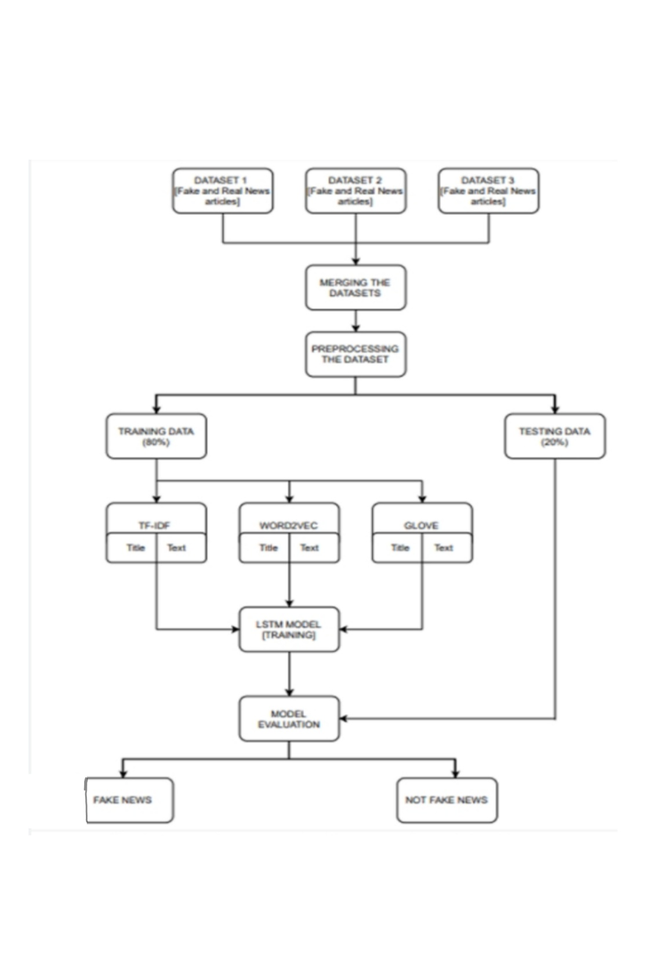

**Team Members:**

**S.Dhanushiya.**

**k.Jelsiya.**

**J.Vijaya.**

**J.Narmatha.**